**The true Antarctic species, those that breed on or near continental Antarctica**

[More](https://www.coolantarctica.com/Antarctica%20fact%20file/wildlife/adelie-penguin.php)

**Emperor penguin**Aptenodytes forsteri  
  
[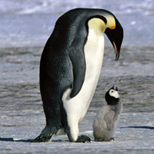](https://www.coolantarctica.com/Antarctica%20fact%20file/wildlife/emp14.jpg)

**Height**: 1.15m - 3.8ft  
  
**Weight**: 30kg - 66lb **Breeding Season:**  
April - December **Distribution:**Continental Antarctica on the sea-ice, the most southerly of all species of penguins. **Estimated population:**  
238, 000 breeding pairs,  
595, 000 individuals

[More](https://www.coolantarctica.com/Antarctica%20fact%20file/wildlife/Emperor-penguins.php)

**King penguin**Aptenodytes patagonica

[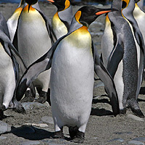](https://www.coolantarctica.com/Antarctica%20fact%20file/wildlife/kings8.jpg)

**Height:** 95cm - 3.1 ft  
  
**Weight:** 15kg - 33lb  **Breeding Season:**  
Starts in November or January, complex breeding system, early or late breeders - raise 2 chicks every 3 years.  
  
**Distribution:**sub-Antarctic islands 46° to 55° South. Biggest colony is on South Georgia. **Estimated population:**  
2 to 3.2 million breeding pairs

[More](https://www.coolantarctica.com/Antarctica%20fact%20file/wildlife/King-penguins.php)

**Rockhopper penguin**Eudyptes crestatus

[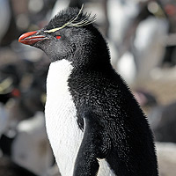](https://www.coolantarctica.com/Antarctica%20fact%20file/wildlife/Rockhopper_Penguin_Liam-Quinn-from-Canada-CC2SaSA.jpg)

**Height:** 55cm - 21.6 inches  
  
**Weight:** 2.5kg - 5.5lb  **Breeding Season:**  
December - March **Distribution:**  
Falkland islands and sub-Antarctic islands north of the Antarctic convergence. **Estimated population:**  
1.8 million breeding pairs  
Many populations are in decline by 40% and up to 94% for certain colonies.